WEEK 8 GIT
SUKHPREET JENA
SUPERSET ID:6399056
EXERCISE 1:
1. Check if Git is installed:
git –version
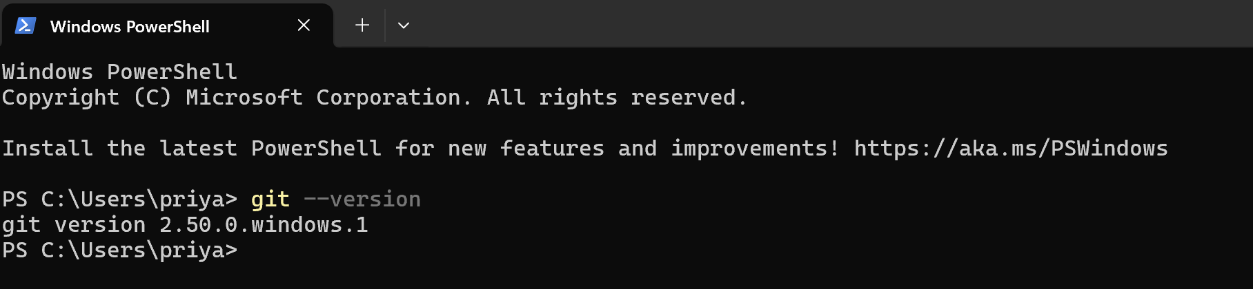
2. Set up Git global user config:
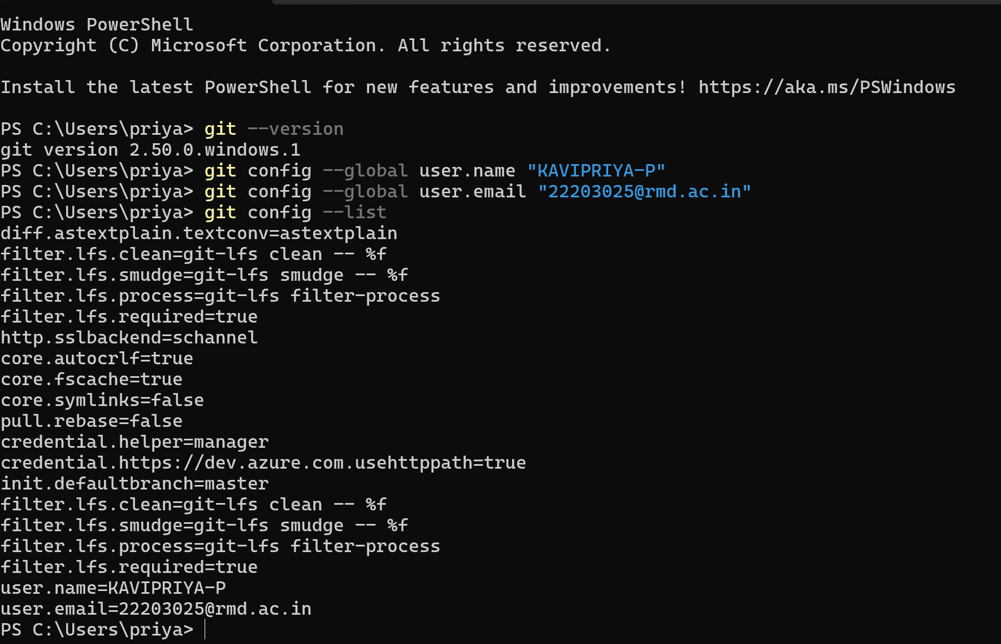

3. Confirm configuration:
git config –list
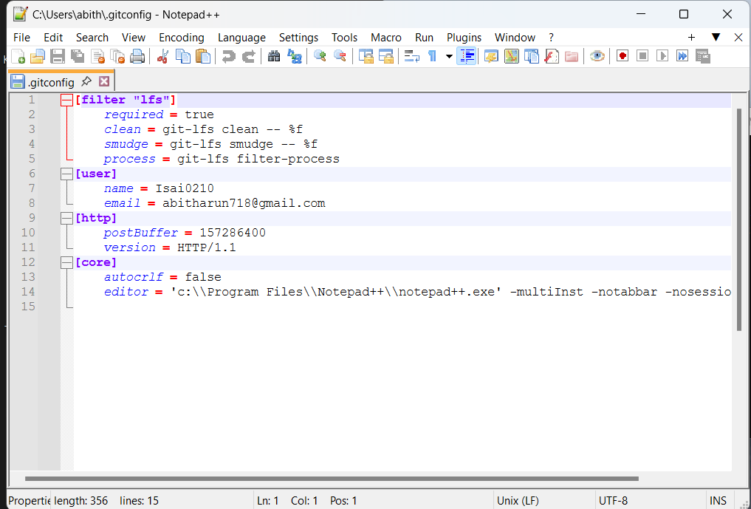

1. Create project folder and initialize Git:
- mkdir GitDemo
- cd GitDemo
- git init
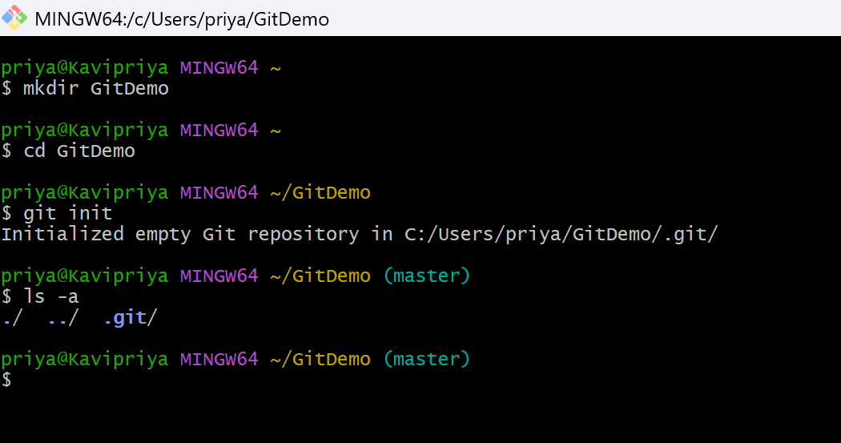
2. Verify Git repo is initialized:
- ls -a
3. Create and edit a file:
- notepad++ welcome.txt
4. Check the file exists:
- ls
5. View the content:
- cat welcome.txt
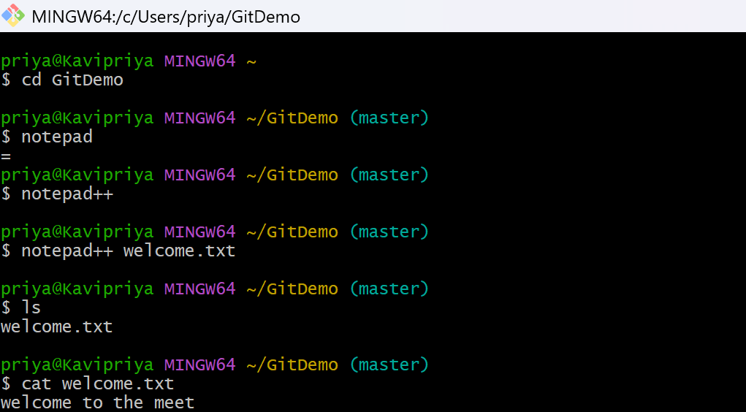
6. Check Git status:
- git status
7. Stage the file:
- git add welcome.txt
8. Commit with multiline message (opens Notepad++):
- git commit
9. Confirm file is committed:
- git status
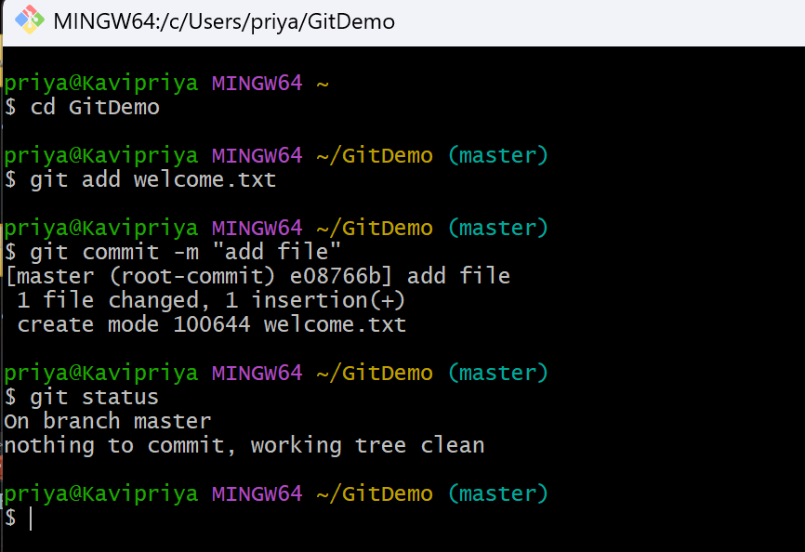

Connect to Remote Repository:
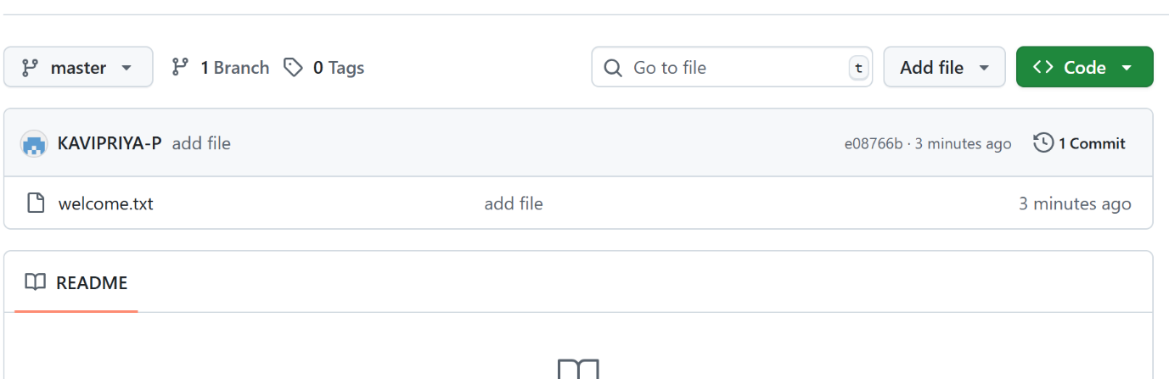

EXERCISE 2:
cd ~/GitDemo
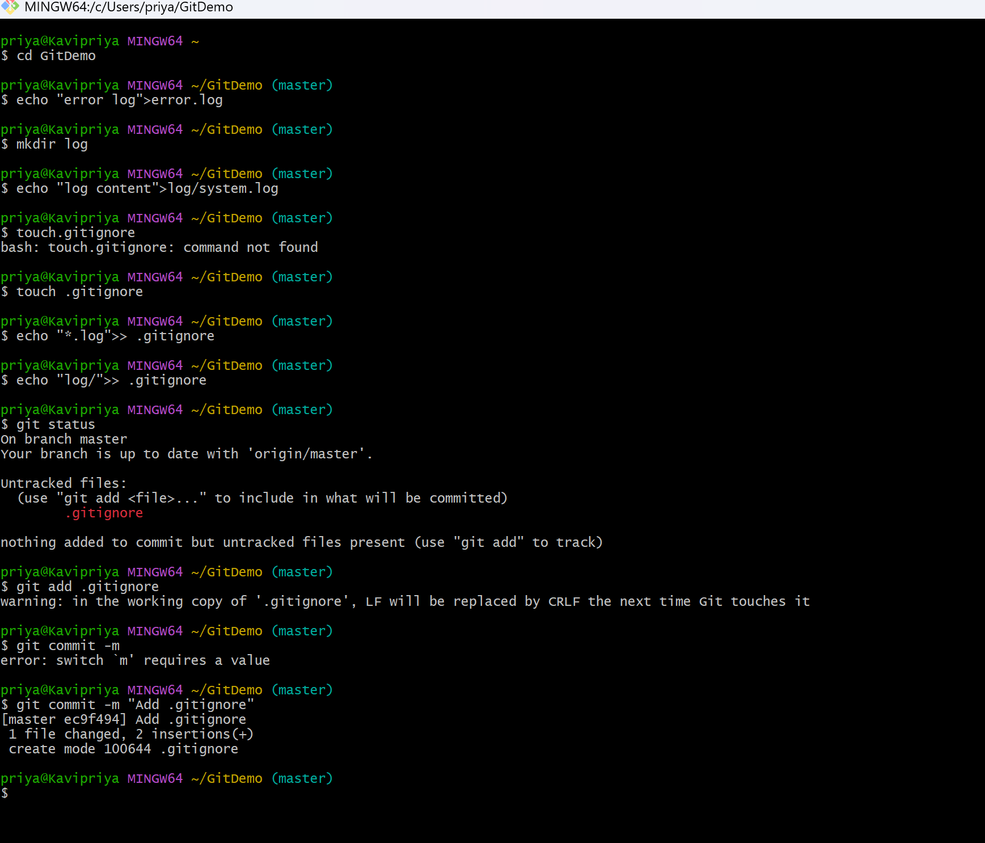
Create test files and folder to ignore
- echo "error log" > error.log
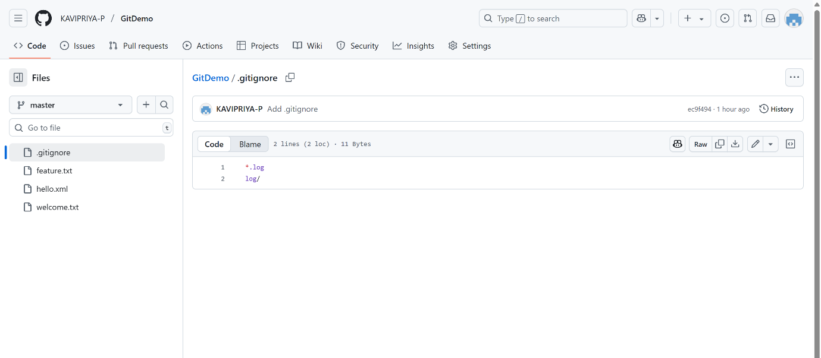
- mkdir log
- echo "log content" > log/system.log
Create a .gitignore file
- touch .gitignore
- echo "*.log" >> .gitignore
- echo "log/" >> .gitignore
- *.log
- log/
Check Git status
- git status
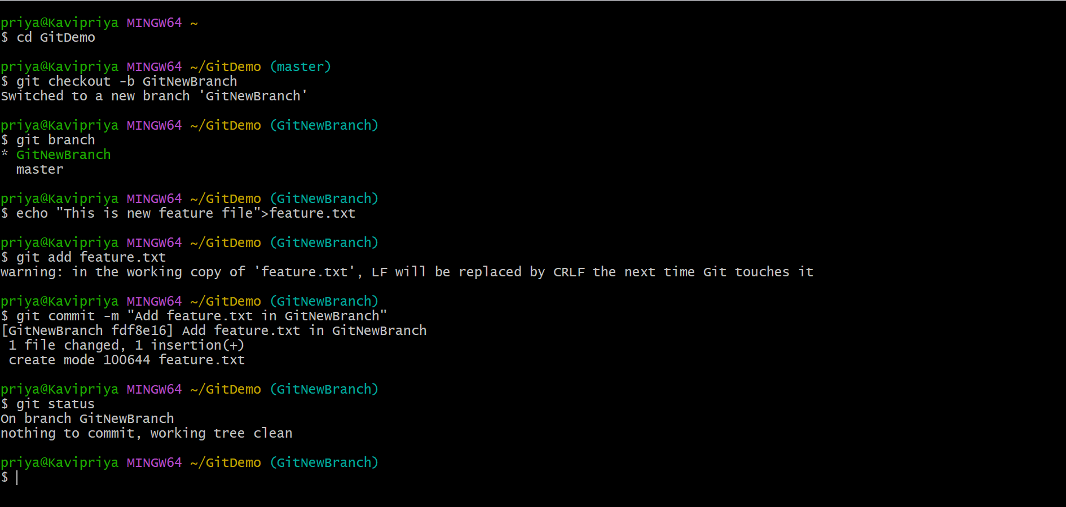

Add and commit only .gitignore
git add .gitignore
git commit -m "Add .gitignore to ignore .log files and log/ folder"
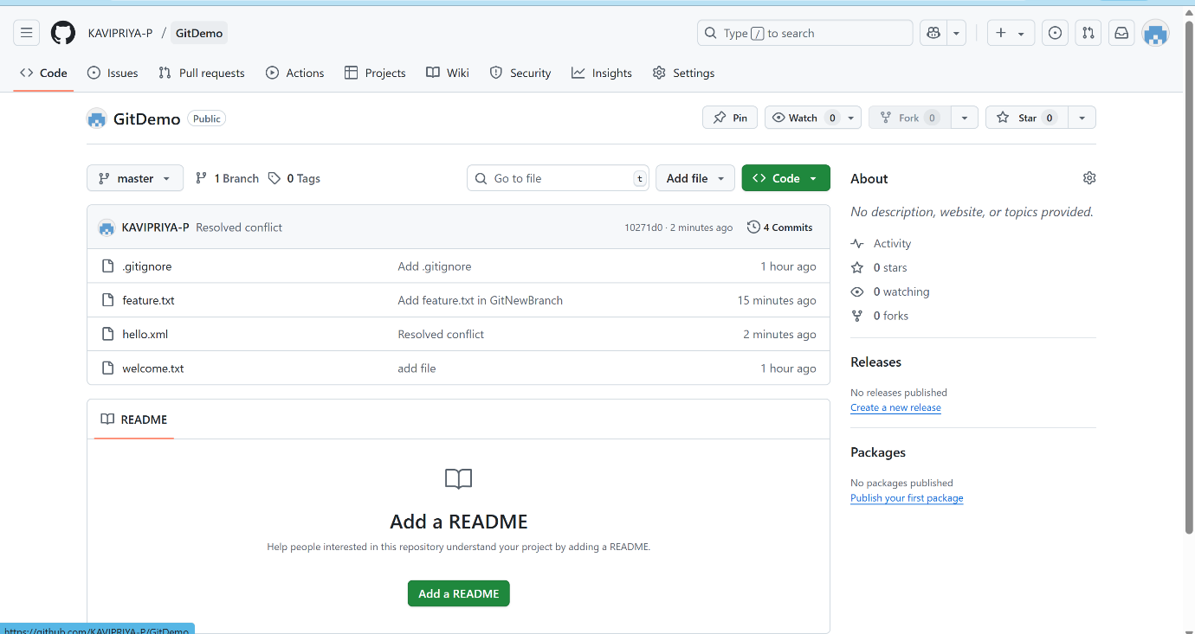

EXERCISE 3:
Create a new branch called GitNewBranch
git checkout -b GitNewBranch


List all branches
git branch
Add a new file in this branch
echo "This is a new feature file" > feature.txt
Stage and commit the file
git add feature.txt
git commit -m "Add feature.txt in GitNewBranch"
Check branch status
git status
MERGING
Switch back to the master branch
git checkout master
Check differences between master and GitNewBranch
git diff master..GitNewBranch
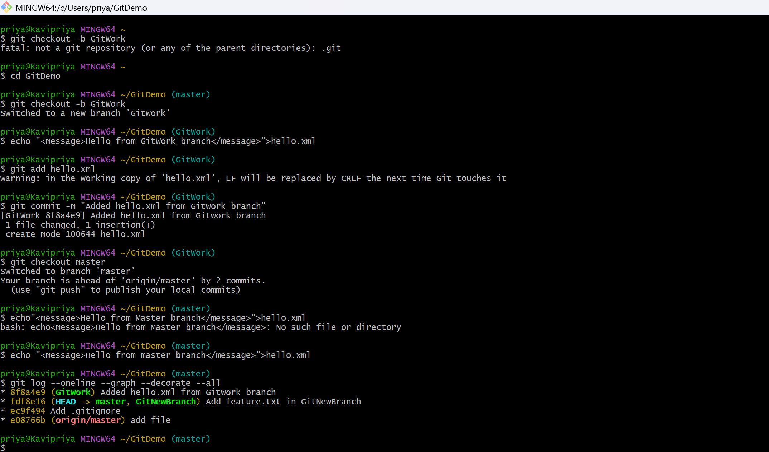
Merge GitNewBranch into master
git merge GitNewBranch
Delete the merged branch
git branch -d GitNewBranch
git status
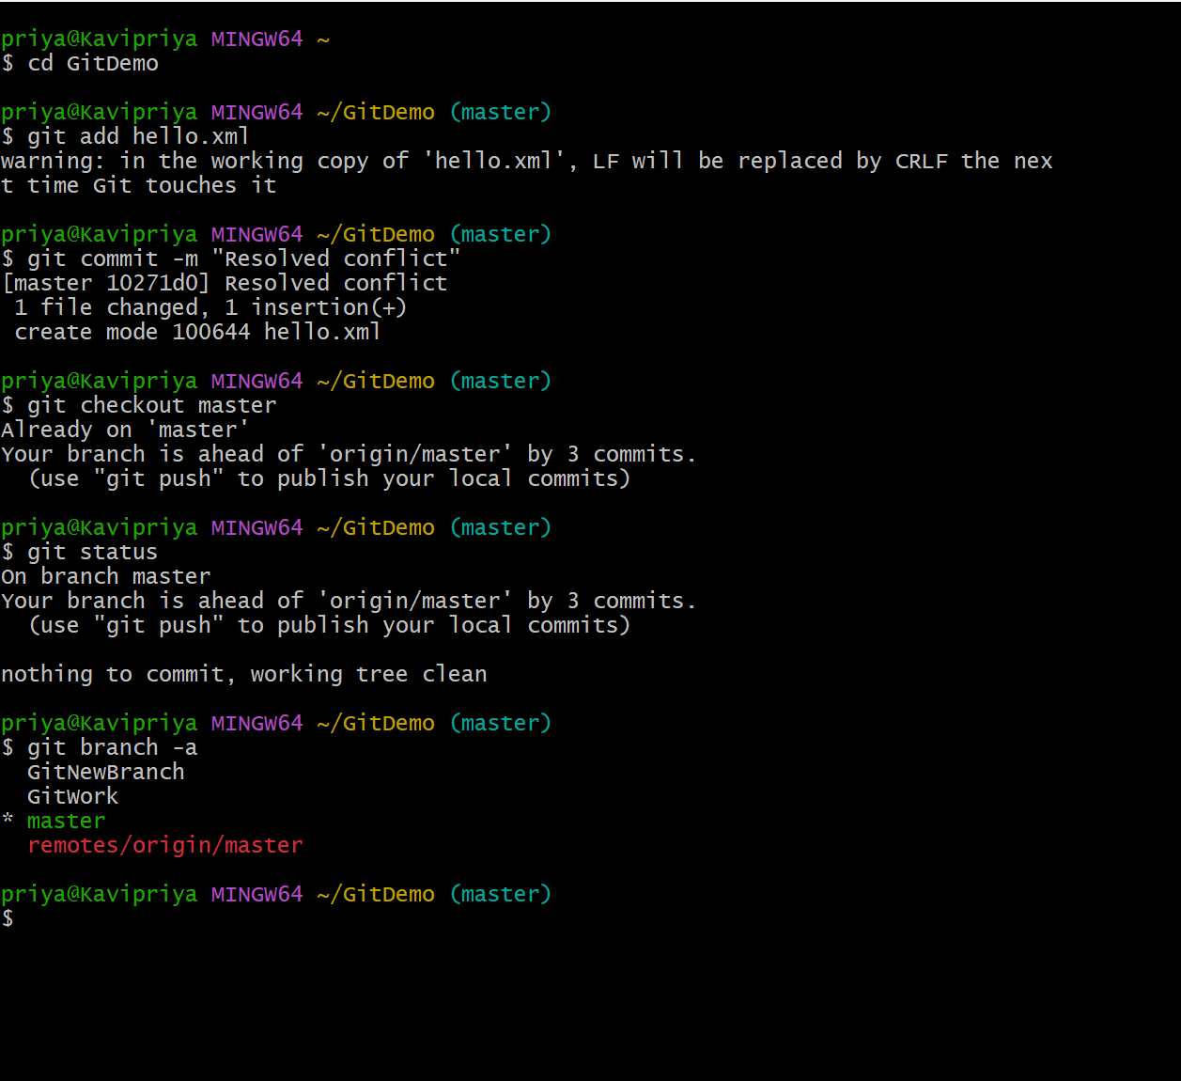
EXERCISE 4:
Create a new branch GitWork and switch to it
git checkout -b GitWork
Add a file hello.xml and update its content
echo "<message>Hello from GitWork branch</message>" > hello.xml
Stage and commit the file
git add hello.xml
git commit -m "Added hello.xml from GitWork branch"
Switch back to master
git checkout master


Add a different version of hello.xml in master
echo "<message>Hello from master branch</message>" > hello.xml
Commit changes in master
git add hello.xml
git commit -m "Added hello.xml from master branch"
View logs in graph format
git log --oneline --graph --decorate –all


Check differences using CLI tool
git diff master GitWork
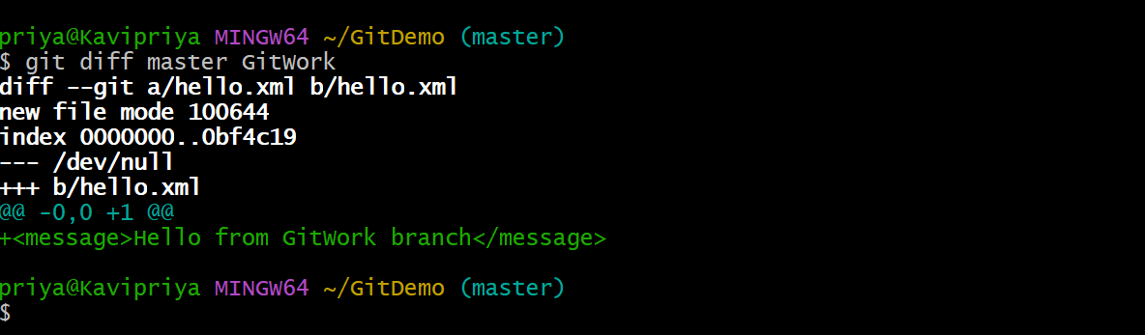

Merge GitWork into master
git merge GitWork
Commit after resolving conflict
git add hello.xml
git commit -m "Resolved merge conflict in hello.xml"
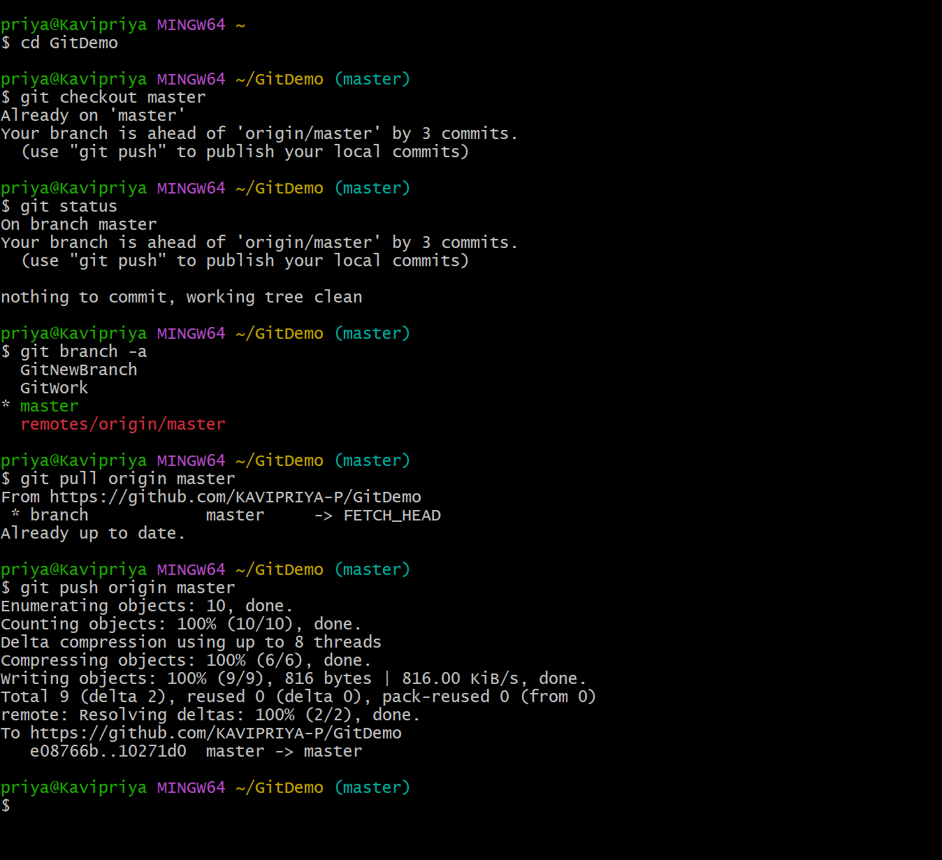

EXERCISE 5:
Verify if master is in clean state
git checkout master
git status
List all available branches
git branch -a
Pull latest changes from remote
git pull origin master
Push your local commits to remote
git push origin master




